**PRACTICAL-4**

**AIM :** **CREATE THE GIVEN TABLES AND INSERT THE DATA ACCORDINGLY.**

1. Retrieve all data from employee, jobs and deposit.

* ***SELECT * FROM EMPLOYEE_18100;***
* ***SELECT * FROM JOB_18100;***
* ***SELECT * FROM DEPOSIT2_18100;***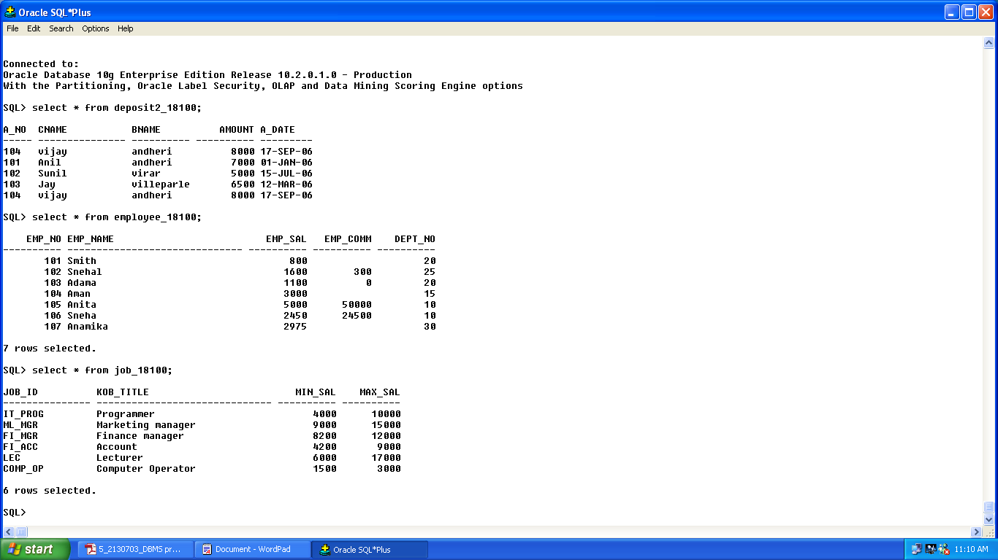

2. Give details of account no. and deposited rupees of customers having account opened between dates 01-01-06 and 25-07-06.

* ***SELECT A_NO,AMOUNT FROM DEPOSIT2_18100 WHERE A_DATE BETWEEN '01-JAN-2006' AND '25-JUL-2006';***

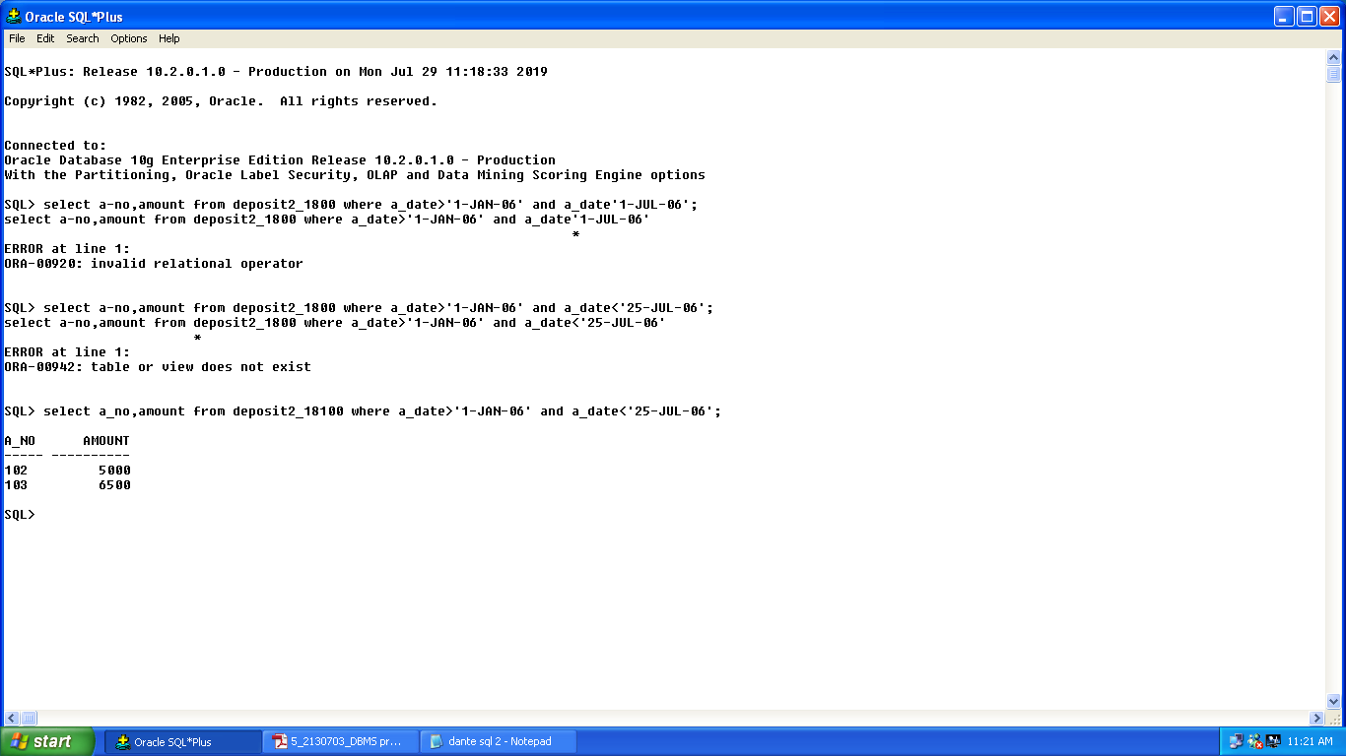

3. Display all jobs with minimum salary is greater than 4000.

* ***SELECT JOB_TITLE FROM JOB_1525 WHERE MIN_SAL>4000;***

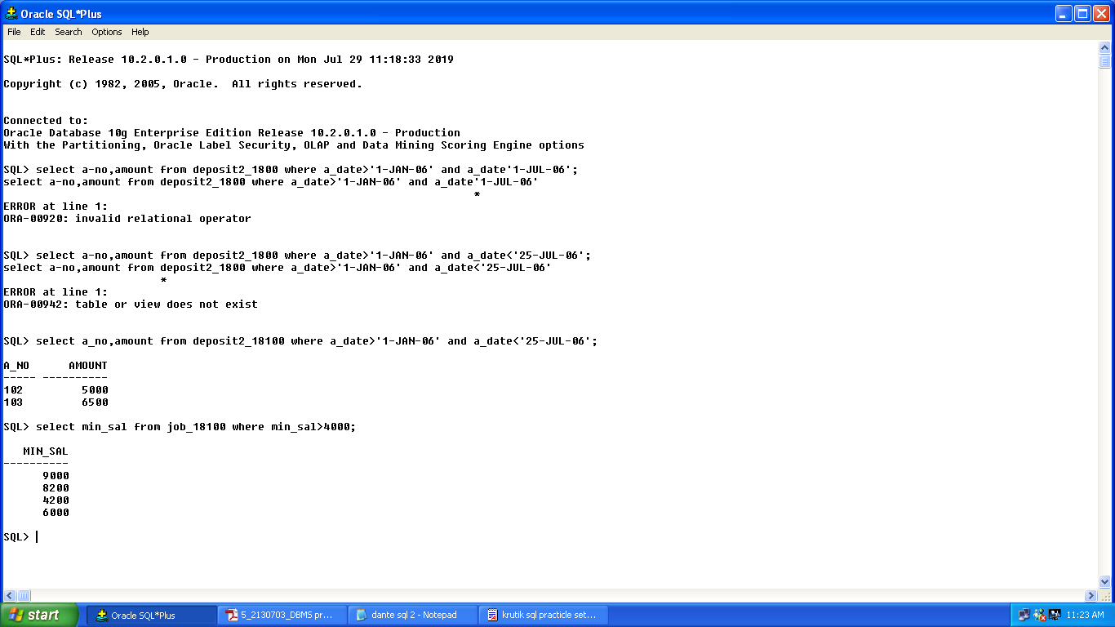

4. Display name and salary of employee whose department no is 20. Give alias name to name of employee.

* ***SELECT EMP_NAME AS "EMPLOYEE",EMP_NAME,EMP_SAL FROM EMPLOYEE_1525 WHERE DEPT_NO=20;***

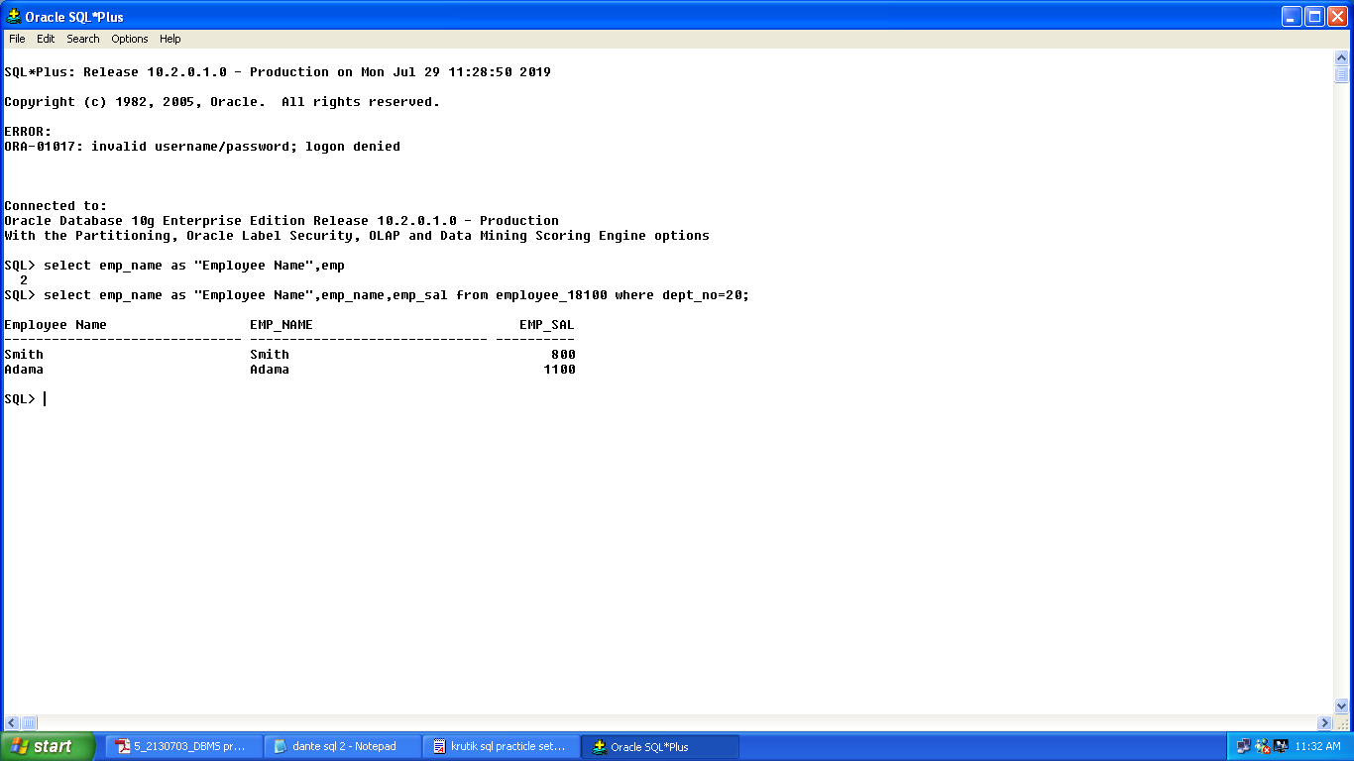

5. Display employee no,name and department details of those employee whose

department lies in(10,20)

* ***SELECT EMP_NO,EMP_NAME FROM EMPLOYEE_1525 WHERE DEPT_NO IN(10,20);***

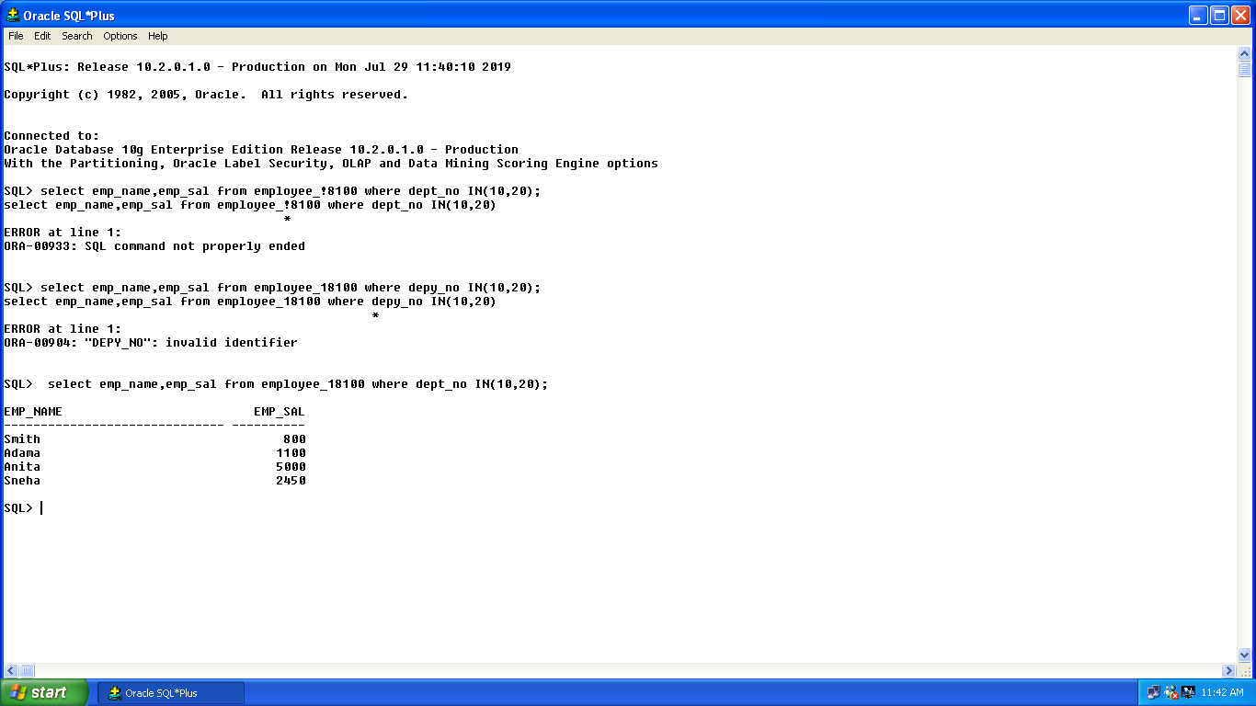

**(LIKE PREDICATE):**

1. Display all employee whose name start with ‘A’ and third character is ‘a’.

* ***SELECT EMP_NAME FROM EMPLOYEE_1525 WHERE EMP_NAME LIKE 'A_a%';***

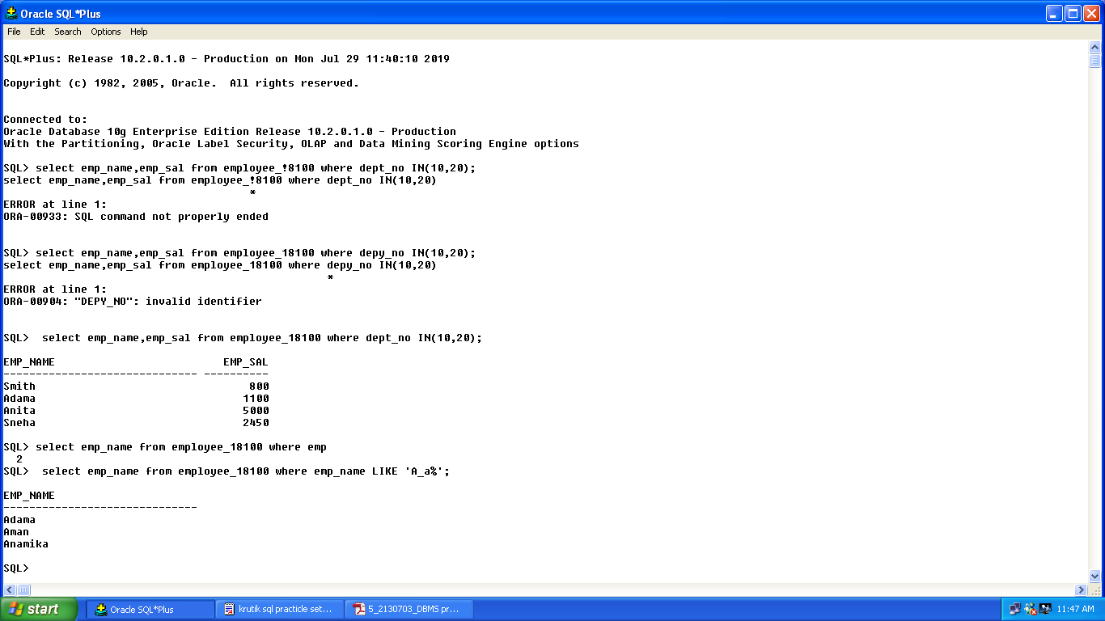

2. Display the non-null values of employees and also employee name second character should be ‘n’ and string should be 5 character long.

* ***SELECT * FROM EMPLOYEE_1525 WHERE EMP_COMM IS NOT NULL AND EMP_NAME LIKE '_n___';***

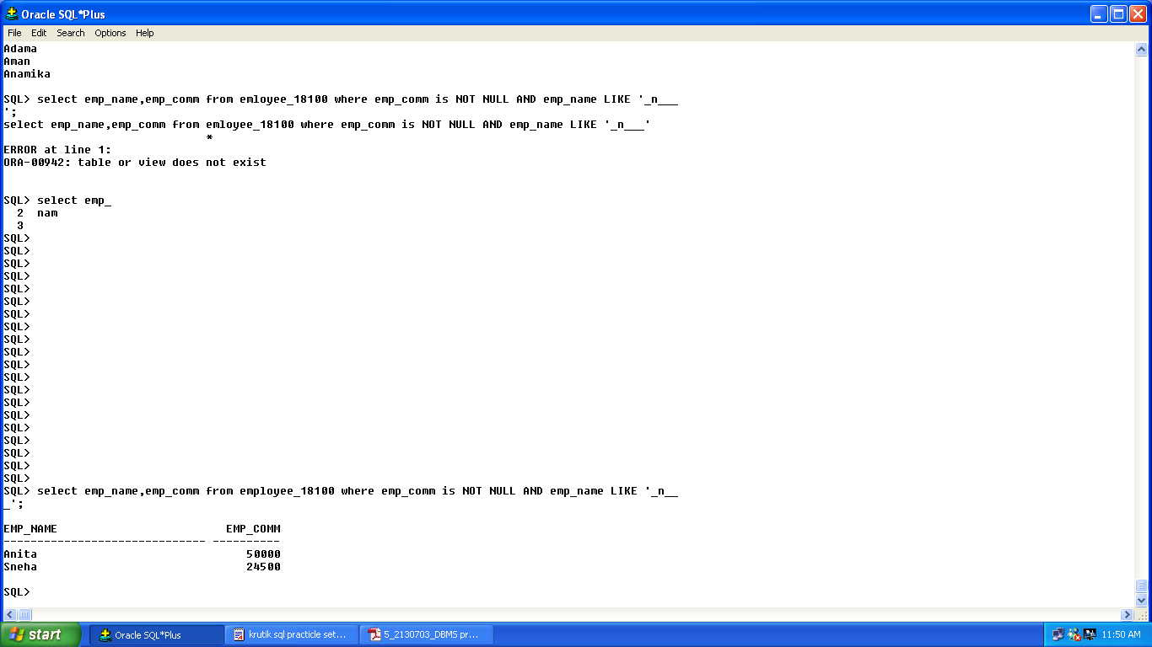

2. Display name, number and salary of those employees whose name is 5 characters long and first three characters are ‘Ani’.

* ***SELECT EMP_NAME,EMP_NO,EMP_SAL FROM EMPLOYEE_1525 WHERE EMP_NAME LIKE 'Ani__';***

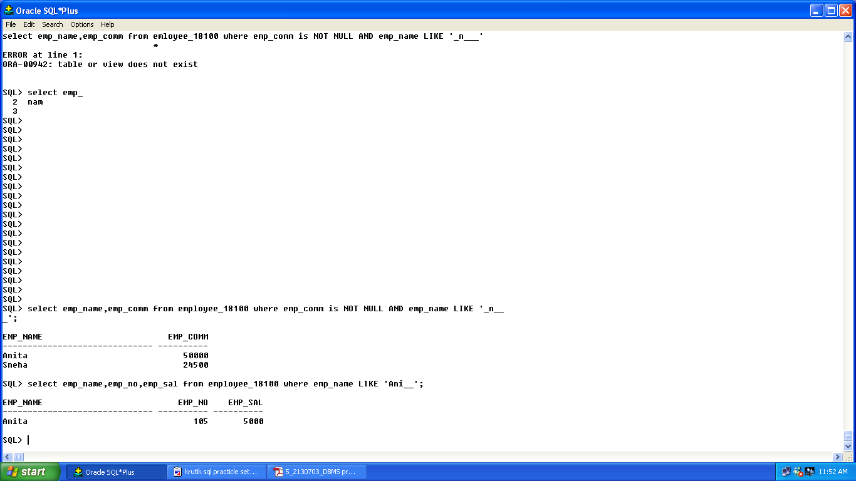

4. Display the null values of employee and also employee name’s third character should be ‘a’.

* ***SELECT * FROM EMPLOYEE_1525 WHERE EMP_COMM IS NULL AND EMP_NAME LIKE '__a%';***

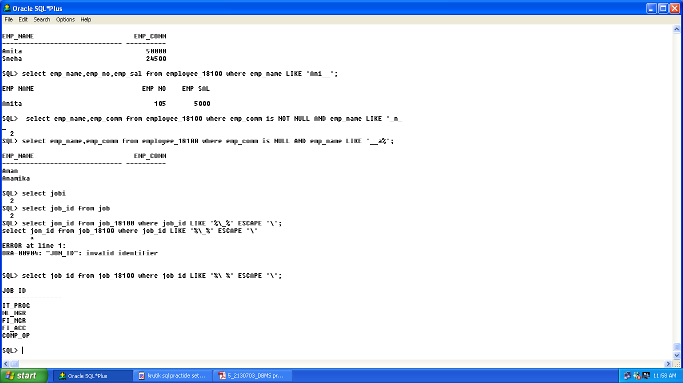

5. What will be output if you are giving LIKE predicate as ‘%\_%’ ESCAPE ‘\’

* ***SELECT * FROM JOB_1525 WHERE JOB_ID LIKE '%\_%' ESCAPE'\';***

